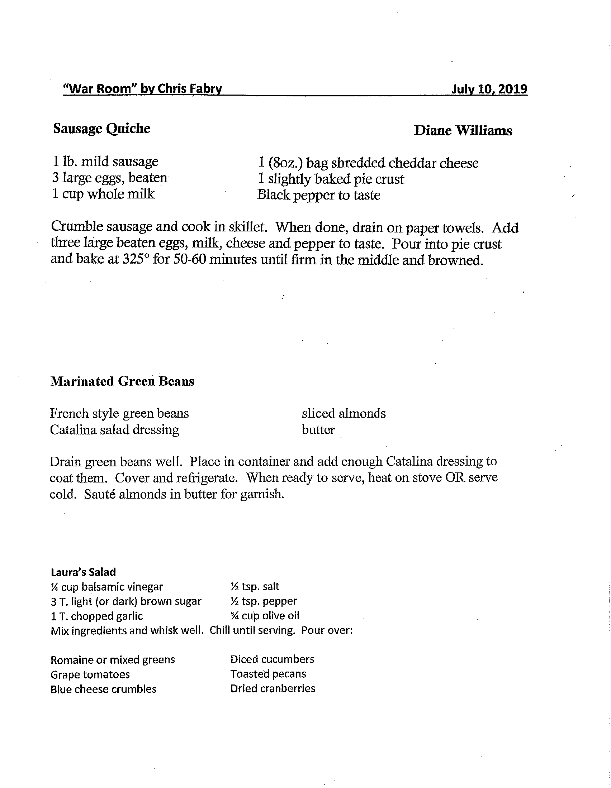

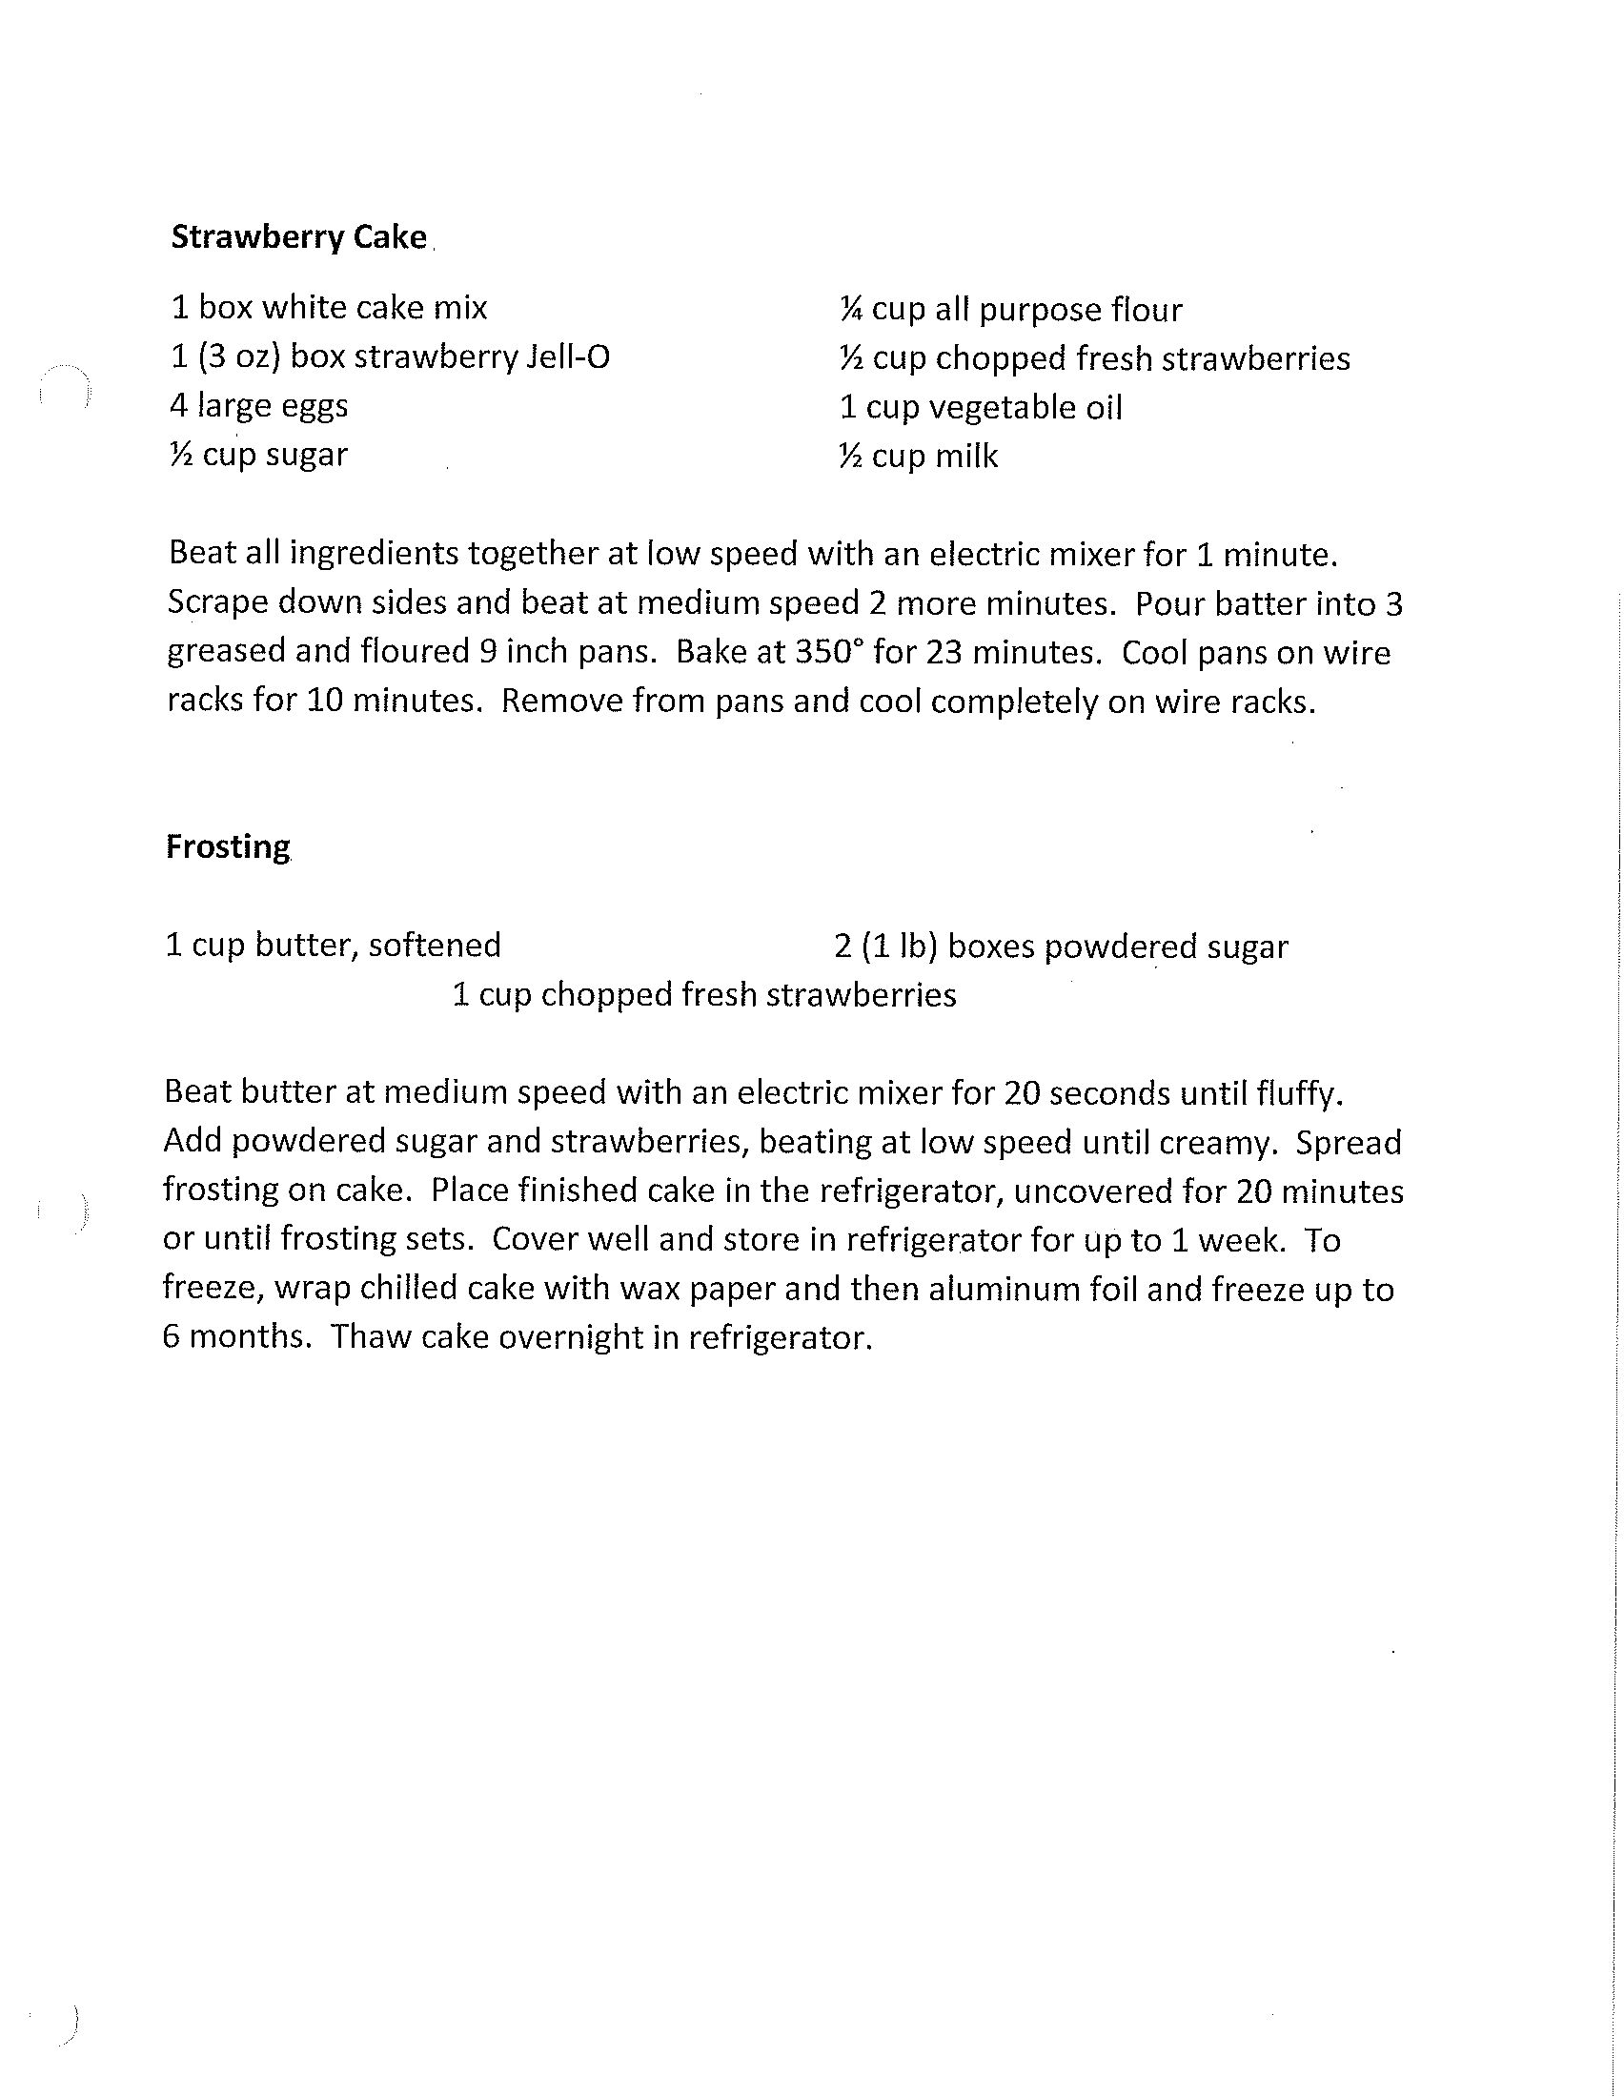

“The Leader’s Wife” by Debbie Thompson June 12, 2019

Chicken Salad

2.5 lbs. cooked, shredded chicken 1 cup sliced seeded grapes
½ tsp. lemon juice ½ tsp. black pepper
¾ cup chopped pecans ½ tsp. celery salt
2 ½ T. diced red onion ½ tsp. salt
1/3 cup diced celery ½ tsp. sugar
2 cups mayonnaise

Mix all ingredients and refrigerate. The flavors blend if prepared a day ahead.
Serves 10

Gingersnap Pear Salad

10 gingersnaps 1 T. mayonnaise
1 (3 oz.) package cream cheese, 8 canned pear halves, drained
at room temperature Chilled crisp lettuce

Crush gingersnaps very fine. Mix with cream cheese and mayonnaise. Place pear halves on bed of lettuce. Fill the hollows with cream cheese mixture.

Spinach Salad Gwen Thompson

Baby spinach 1 jar pearl onions, drained
3 small cans mandarin oranges 1 pkg. slivered almonds

Dressing: 1 cup sugar ½ tsp. paprika
½ tsp. dry mustard 1 tsp. salt
1/8 tsp. Worcestershire

2 cups salad oil ½ cup cider vinegar
1 small jar sesame seeds, toasted

Toast sesame seeds until brown and set aside. Combine first five ingredients in blender, add oil and vinegar slowly. When mixed, add sesame seeds and chill. Put salad ingredients together, add dressing and toss.

Lemonade Pie Abby Johnson

1 (8 oz) Cool Whip 1 (6 oz.) can frozen lemonade
1 can sweetened condensed milk 1 graham cracker crust

Thaw lemonade. Whip ingredients together and pour into graham cracker crust. Freeze until serving.

